**BUSINESS PLAN**

(Online)

MPU 22012

ENTREPRENEURSHIP

GROUP 1

MRZ_PASTA

DET4C

|  |  |
| --- | --- |
| MUHAMMAD AQIL LUQMAN BIN NOIDAN | 03DET22F1035 |

**1. Business Information using BMC template and SWOT analysis**

**- BMC Template**

- Key Partners: Local pasta suppliers, soda distributors.

- Key Activities: Cooking, packaging, marketing, customer service.

- Key Resources: Kitchen equipment, social media accounts, delivery vehicles.

- Value Proposition: Fresh, homemade pasta dishes paired with refreshing sodas.

- Customer Relationships: Direct communication through social media, feedback collection.

- Channels: Facebook, Instagram, WhatsApp.

- Customer Segments: Pasta enthusiasts, busy individuals, families.

- Cost Structure: Ingredient costs, labour costs, marketing expenses.

- Revenue Streams: Pasta sales, soda sales, delivery fees.

- **SWOT Analysis**

- Strengths: Unique homemade pasta recipes, niche market focus.

- Weaknesses: Limited brand recognition, small customer base.

- Opportunities: Collaborations with local cafes, expansion to nearby neighbourhoods.

- Threats: Competition from larger pasta chains, fluctuating ingredient prices.

2. **Facebook**

-**Facebook Page**

- Cover photo: Mouthwatering image of pasta dishes and soda bottles.

- Profile picture: Pasta & Soda Small Business logo.

- Admin Role: Managed by owner/operator.

- Number of Likers: 100 followers.

**-Posts on Page**

- Teaser: "Craving authentic pasta? Pair it with our refreshing sodas for the perfect meal!"

- Soft sell: "Try our signature carbonara - made with love and locally sourced ingredients."

- Hard sell: "Limited time offer: Free soda with every pasta order!"

**- Custom URL FB Page**

<https://www.facebook.com/profile.php?id=61556624730892&mibextid=ZbWKwL>

**-About Us and Insight**

- About Us: Pasta & Soda Small Business specializes in serving homemade pasta dishes paired with a selection of handpicked sodas. Our mission is to bring comfort and joy to every meal with our delicious creations.

**3. Instagram**

**Profile**

- Profile picture: Same as Facebook.

- About Us: Your go-to destination for fresh pasta and flavourful sodas.

- Number of followers: 191.

- Post: Vibrant photos showcasing pasta dishes and soda pairings.

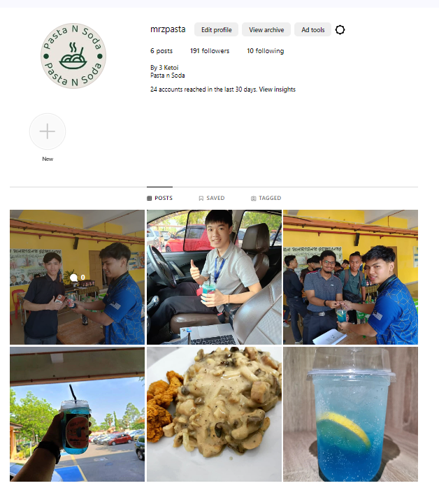

**- Caption and Hashtag**

- Caption: "Indulge in the simple pleasures of life with our pasta and soda combos! #PastaSodaLove #HomemadeGoodness"

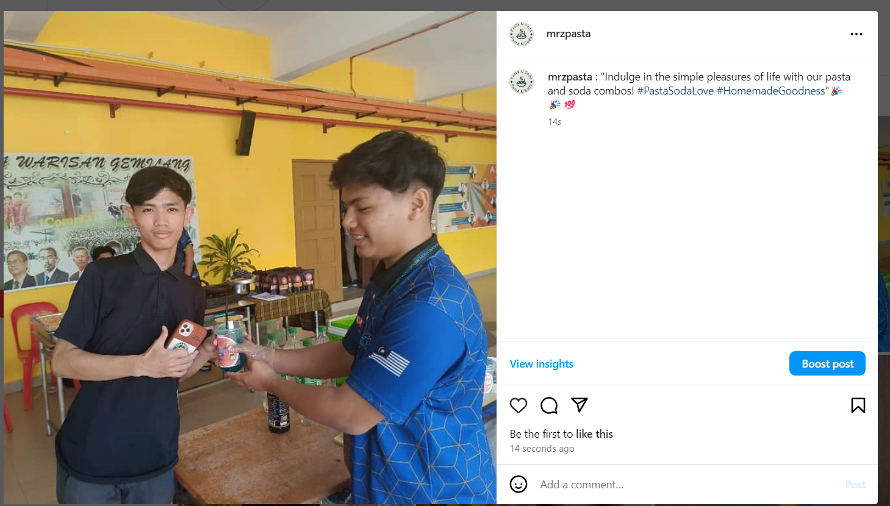

**4. Deals**

**- Communication Channels**

- WhatsApp/email/SMS/comments: Prompt responses to inquiries and orders via WhatsApp.

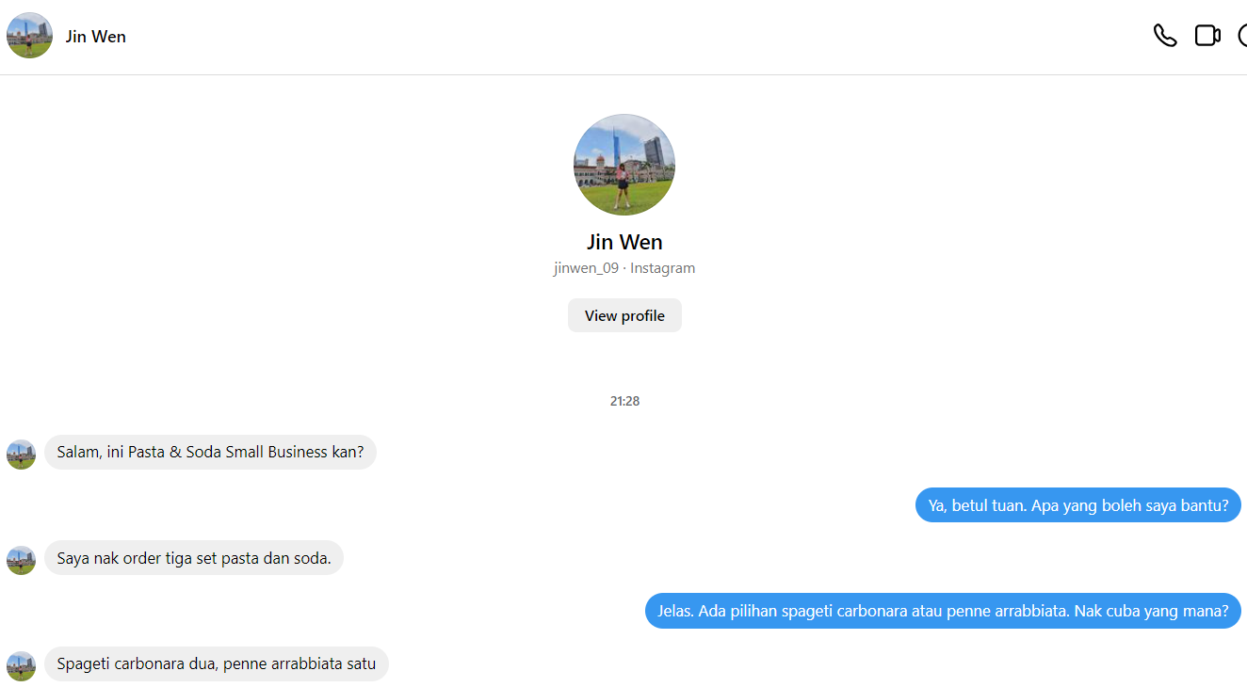

**- Enquiries**

- Handling inquiries: Personalized responses addressing customer queries and dietary preferences.

**- Closing Deals**

- Process: Smooth order placement and payment via WhatsApp.

- Bank In Slip: Provided upon confirmation of order.

TNG

**- Testimonials**

- "Absolutely loved the spaghetti Bolognese from Pasta & Soda! The soda pairing was a delightful surprise." - David, satisfied customer.

**5. Financial**

- Sales: Monthly sales averaging RM 500.

- Profit: Net profit margin of 15%.

**6. Experience, Recommendation and Future Planning**

- Experience: Pasta & Soda Small Business has established a loyal customer base through its homemade pasta dishes and curated soda selection.

- Recommendation: Increase brand visibility through local events and collaborations with neighbouring businesses.

-Future Planning: Expand menu offerings to include vegan and gluten-free options to cater to a wider audience. Consider offering meal bundles for families and larger groups.

This report outlines a comprehensive social media marketing strategy for Pasta & Soda Small Business, focusing on its unique value proposition, engagement tactics, financial performance, and future growth opportunities.